Standard Operating Procedure (SOP), Instron Mechanical Tester
THIS INSTRUMENT RREQUIRES TRAINING BY INSTRUCTOR
SOP ver.1 (2024.08.27)

Instron Mechanical Tester has the following risks. Check Risk Assessment before starting to use!
- A hand caught in the machine
- A finger caught in the clamps
- Load cell break by operation without safety limit setting
- Cutting your hand with a cutter while preparing the samples

Starting up the Instron
- Check air supply
  - Air pressure should be more than 6 bar
- Check the load cell and clamps
  - Standard load cell: 5 kN new load cell (± 0.5% of reading down to 5 N)
  - Standard clamps: New tensile clamp, Old tensile clamp or Compression fixture
  - If you would like to use a non-standard clamp system, contact the machine responsible
- Turn on Instron (Right rear of the machine)
- Turn on PC and log in (Account: lab-user, Password: no password)
- Open Instron software from PC and log in (Account: CHALMERS, Password: CHALMERS)

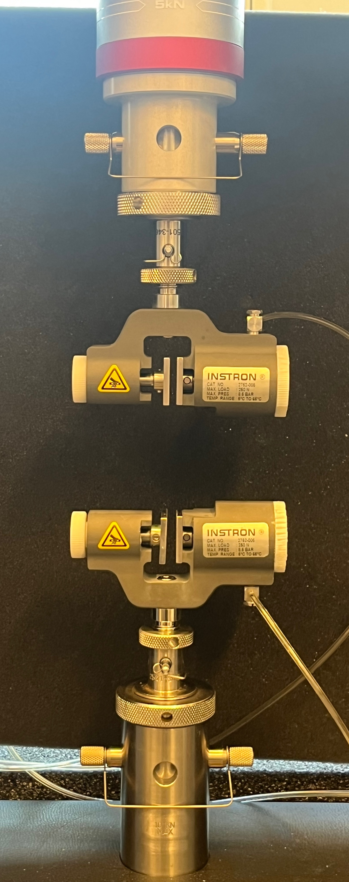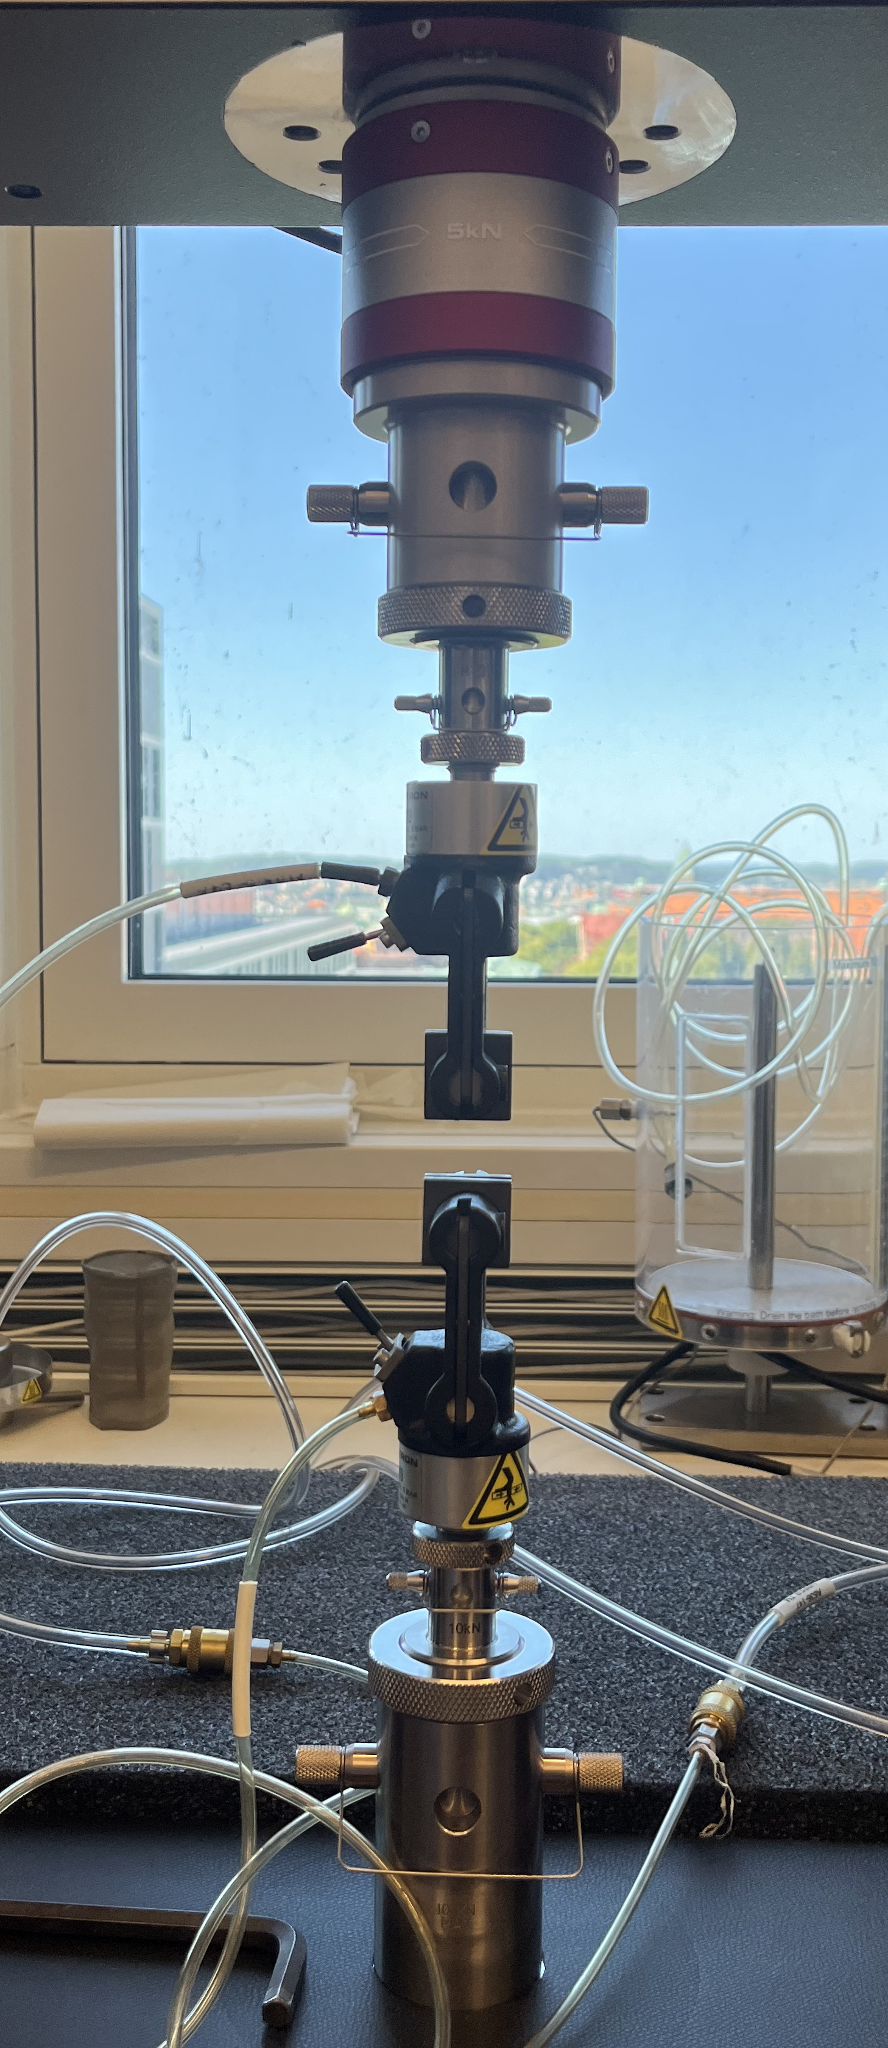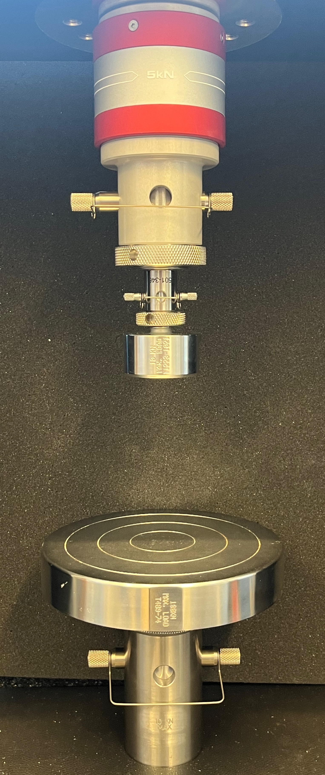
New tensile clamp, Old tensile clamp, Compression fixture
Method Preparation
- Click “Methods”
- Select a method or create a method from zero.
The software is very complex, so we recommend using our Template Method.
- “Template Method, New tensile clamp”
- “Template Method, Old tensile clamp”
- “Template Method, Compression Fixture”
If you start the method from zero, the load cells may crash each other during the test or auto-positioning, depending on the setting. Contact instructors or experienced staff. Use the safety lock system and pay maximum attention when you use your method's auto-positioning function for the first time.

- Modify “Fixture Length” in “Sample” tab depend on your test condition
- The rest of the section can be modified at this time but also can be modified during the test
- Template Method already includes the clamps length information (XX tab), so don’t touch here.
- The standard “Grip air pressure” is 4.0 bar. This should not be 6.0 or more. This will lead to errors.
- Save as the method with your new name (you can keep using this next time)

Test Measurement
- Click the “Test”
- Open created your method
- Auto-position: software shows you the displacement to go to the “Fixture Length” you set in your method
- Check the displacement will not make the clamps crash each other!!
- Move safety lock system positions so as not to make the clamps crash.
- Press the “Unlock” and then the “Return” button
- Now, the clamp is already in the starting position
- Input test information
  - Sample

- Input a sample information
  - Width
  - Thickness
  - Deformation rate

- Start a test with the press of the “Unlock” and “Start” buttons on the machine
- Once you get a result, leave a memo following the pop-up instructions
- Repeat measurements
- Calculation conditions, etc., can be changed during the test using the Method tab. Make sure to save the method after the modification.

Finish the Measurement
- Click the “Finish” icon
- The raw data, PDF report (the style can be changed from method), and CSV files are automatically saved into the folder you set during the test.
- Export data to your PC through the internet (you can leave your data on this computer but not guarantee the backup)
- Close the software
- Turn off PC (only recommended if it is before a long holiday)
- Turn off Instron, Right rear of the machine (only recommended if it is before a long holiday)

NOTIFY THE INSTRUMENT RESPONSIBLE OF ANY ERRORS OR MISFUNCTIONING

